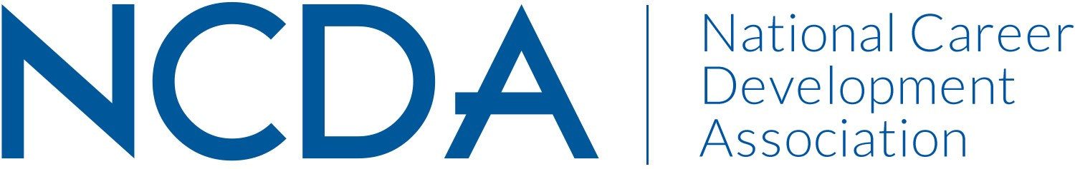

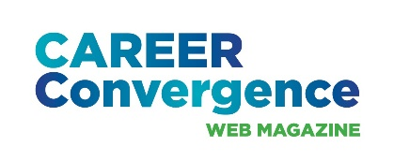
NCDA ANNUAL REPORT

CAREER CONVERGENCE WEB MAGAZINE
March 3, 2026

Editor: Melanie Reinersman, webeditor@ncda.org
Associate Editors: Natasha Barnes, David Dietrich, Jane Frisch, Candina Janicki, Vonya Hodrick, Maisie Lynch, Jill Minor, Elyse Pipitone, Billie Streufert
Field Editors: Mason Murphy, Gaeun Seo, Regina Gavin Williams

Committee Activities to Date

- Published new issues on the first of each month (except Jan.) bringing the total issues up to 238, since 2003 (Strategic Goal #2- Career Empowerment: Publications)
  - Published 7 new articles, plus one Tech Tip, each month. Electronic distribution to over 30,000 emails and over 1700 articles archived
- Held zoom meeting in Dec. 2025 with 9 editors
- Monitored new auditory player plug-in, (for articles posted April 2025 and after) (Strategic Goal #1- Community: Engagement)
  - Avg monthly clicks: 235 (up from 150 last year’s average); Highest Month Clicks: 240 (Nov);
- Achieved record-high hit rates for articles related to K-12 strategies, theory, AI, Universal Design and ADHD (Strategic Goal #2- Career Empowerment: Publications)
- Selected 2026 winner (by editors’ votes) the annual “Career Convergence Recognition Award” – Cynthia Snodgrass & Vonya Hodrick, winner (Strategic Goal #1- Community: Engagement)
- Published articles in cooperation with NCDA committees/programs, e.g., The HUB, Awards & NCD month; discussed potential collaboration with another committee (AEO) (Strategic Goal #1- Community: Engagement)
- Social media each month handled by NCDA Social Media coordinator, with links to the issue and each article, increasing hit rates (Strategic Goal #1- Community: Recruitment)

Projected Plan/Work Planned to be Completed through September 30.

- Continue to publish monthly issues of the web magazine
- Review AI publication recommendations
- Present at Global Conference in Minneapolis and Virtual Conference

