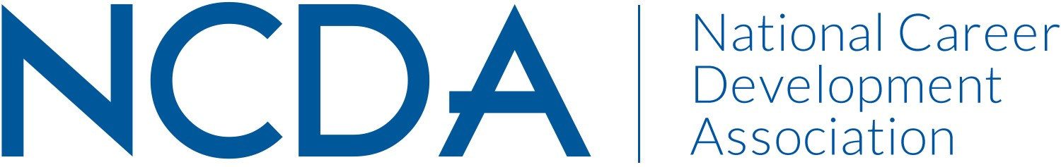

NCDA AWARDS COMMITTEE
March 6, 2026

List of Chair and Co-Chair(s) with full contact information and e-mail address
- Chair, Delasia Rice, drice13@forham.edu, (212) 903-2052, Graduate School Specialist
- Co-Chair, Emily Gomez , egomez@hireheroesusa.org, (916) 956-8476, Employee Experience Manager

List Committee Members (no contact information required)
- Jessica Ayub
- Soonhoon Ahn
- Sujata Ives
- Amanda Cox
- Natalie Kauffman
- Scott Fisher
- Elvis Sio
- Julie Higgs
- Ellen Goodman

Committee/Council Activities to Date

- Started and completed the 2025 – 2026 Award Nomination season; meetings are currently scheduled for late March to select the 2026 Award winners
- Began process of expanding the Outstanding Career Practitioner Award to include a winner from each of the 4 constituencies: co-chairs have met with each of the constituency trustees to gather their ideas for the award
- Began the process of developing a new and approved rubric to make award selection process simpler smoother – member Julie has developed a draft of a new rubric
- Developed process to make nomination and applications easier for NCDA members

Projected Plan/Work Planned to be Completed through September 30.

- Will be selecting new co – chairs to start for the 2026 – 2027 year
- Will be working on drafts of all new rubrics to be able to present in either June or September’s board meeting
- Will be drafting a proposal for the 4 Outstanding Career Practitioner awards to present in either June or September’s board meeting
- Will be developing FAQ and Nomination application tips to display on website in hopes of smoother process and in turn getting more nominations

