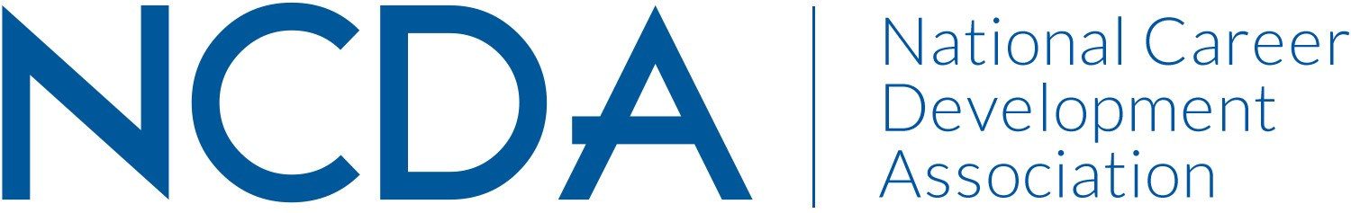

NCDA COMMITTEE REPORT FORMAT

CAREER DEVELOPMENT QUARTERLY (CDQ)
3/6/2026

Melinda M. Gibbons, Editor
Professor and Academic Unit Director
Counselor Education Programs
450 Claxton Building, CHDFS
University of Tennessee
Knoxville, TN 37996
Mgibbon2@utk.edu

Seth Hayden, Associate Editor
Louis Rocconi, Assistant Editor, Quantitative Methods
Byeolbee Um, Assistant Editor

Committee/Council Activities to Date
- Completed 2025 with four published issues, 26 articles total
- Received 332 manuscript submissions in 2025, an increase of 100 manuscripts over 2024
- Increased our editorial board and ad-hoc reviewer numbers to better meet the needs of our increased submissions
- Successfully began our special issue on career development of Black men and boys – with 17 submitted manuscripts for consideration
- Published the March 2026 issue, with seven articles
- Searched for and brought on a new assistant editor, Dr. Um, to support the journal and its growth
- Continued support of the CDQ Spotlight series in Career Developments, providing one article for each issue
- Began a new invited article section to highlight articles from career development and counseling theorists about how to use their theories in practice

Projected Plan/Work Planned to be Completed through September 30.
- Complete the special issue
- Receive submission of at least two invited articles for new section on theories
- Continue to review manuscripts and provide quality feedback in a timely manner

