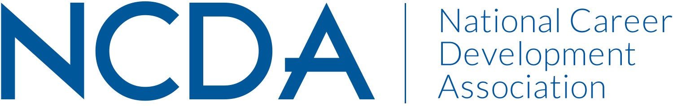

NCDA COMMITTEE MID YEAR REPORT

GLOBAL CONNECTIONS COMMITTEE
March 2026

Chair: Sonja Robinson, Ph.D. | Educator | Program Director at International Samaritan | Consultant | Workforce Development Leader. Portmore, St. Catherine, Jamaica. sonja@intsam.org | +1-876-531-3031

Co-Chair: Hildah Mokgolodi, Ph.D. | Lecturer, University of Botswana. Botsawna.
hlmokgolodi@gmail.com
Co-Chair Elect: The committee acknowledges the contributions of Dr. Sepi Kiazal, who previously served in a leadership role within the GCC and recently resigned due to health reasons. The committee expressed appreciation for her service and dedication to advancing global engagement within NCDA.
Following her resignation, GCC members were invited to submit nominations or express interest in serving as Co-Chair-Elect. The committee is currently reviewing nominations and expressions of interest to identify a suitable candidate to support the leadership team and ensure continuity of the committee’s work.

List Committee Members:
Jaana | Kettunen | Finland
Miwa | Omori | Japan
Joe | Chahwan | Lebanon
Essam Ali Osman A. | Abobakr | Egypt
Randa | Helmi | Egypt
Simon D. | Lee | South Korea
Ahmed | Mostafa | Egypt
Eman G. | Almutiri | KSA
Charmaine | Lewis | Jamaica
Shelley (Hsiu-Lan) | Tien | Taiwan
Afaf Hamad | Almujalli | KSA
Maha Fakhry | Moussa | Egypt
Minobu | Sato | Japan
Jeremiah | Wong | Sinagapore
Rebecca M. | Dedmond | USA
Kelvin (Wai Kit) | Ling | Australia
Dalia A. | AbouZeid | UAE
Marcela | Mesa Guerrero | Colombia
Eman S. | ALyousef | KSA
Effrosyni | Parampota | Qatar
Candy | Ho | Canada
Hildah | Mokgolodi | Botswana
Samantha | Ng | Singapore
Sonja M. | Robinson | Jamaica
Effrosyni | Parampota | Quatar
Amy | Zdanowski | USA
Tina M. | Peterman | USA
Christian D. | Chan | USA
Natalie | Kauffman | USA
Karol I. | Taylor | USA
Rebecca | Flynn | USA
Ellen | Weaver Paquette | USA
Blanca | Rosales-Ahn | USA
Mary Ellen | Earnhardt | USA
Abiola | Dipeolu | USA
Marilyn E. | Maze | USA
Soonhoon | Ahn | USA
Jessica | Ayub | USA
Sujata | Ives | USA
Keith R. | Okrosy | USA
Hyung Joon | Yoon | USA
Sabira | Vohra | USA
Jane | Goodman | USA
Michelle | Gross | USA
Kelly J. | Roberts | USA
Tanisha | Reed | USA
April | McHugh | USA

Committee/Council Activities to Date

- Conducted two virtual Global Connections Committee meetings during the current reporting period to strengthen international engagement, knowledge sharing, and professional collaboration among members. Meeting 1: Hosted a collaborative session featuring representatives from several NCDA committees who presented their committee initiatives, priorities, and opportunities for partnership. This session helped strengthen cross-committee collaboration and encouraged GCC members to engage more broadly with NCDA initiatives. NCDA President Dirk Matthews also addressed the committee during the first meeting, sharing updates on NCDA priorities and encouraging greater global engagement within the association. Strategic Alignment: Supports Cultivating Community through member engagement and collaboration across committees and promotes National and International programs and initiatives.

- Meeting 2: Focused on increasing GCC members’ understanding of NCDA publication opportunities. Featured speakers Melissa A. Venable (Editor, Career Developments) and Melanie Reinersman (Editor, Career Convergence) provided guidance on submission guidelines, article formats, and opportunities for practitioners and researchers to publish their work. The session clarified the distinctions among NCDA’s three primary publications:
– Career Development Quarterly (CDQ) – research journal
– Career Developments – themed membership magazine
– Career Convergence – web-based magazine focused on applied practice.
Discussions emphasized strategies to increase international author participation, encourage collaborative writing among GCC members, and improve accessibility for non-English speaking members. Strategic Alignment: Supports Career Empowerment by encouraging professional development, research dissemination, and diverse authorship in NCDA publications.
- Members were also encouraged to participate in NCDA strategic focus groups, contributing global perspectives to the future direction of the association. Strategic Alignment: Supports Advocacy and visibility of international members within NCDA initiatives.
Projected Plan/Work Planned to be Completed through September 30.

- Continue hosting GCC meetings that provide networking, collaboration, and knowledge exchange opportunities for international members.
- With support from NCDA headquarters, match NCDA Ambassadors to first-time international attendees at the next Conference
- Having a table at the Exhibition Hall for international attendants at the NCDA Conference

