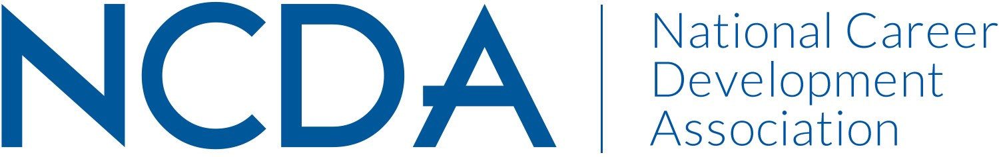

GRADUATE STUDENT MEMBERS COMMITTEE
March 15, 2026

List of Chair and Co-Chair(s) with full contact information and e-mail address
- Chair: Lisa Cardello, lisamcardello@gmail.com
- Co-chair: Vacant (We anticipate filling this position by April 2026)

List Committee Members (no contact information required)
- Delasia Rice
- Kadhem Aljabr
- More coming soon (see note below about interest survey)

Committee/Council Activities to Date (as of 3/15/26)

- Selected new Chair (Lisa)
- Held a transition meeting between new chair (Lisa) and prior co-chair (Delasia)
- Sent out graduate student interest form for NCDA student members to apply for committee roles and/or express interest in volunteering for subcommittees. We received 13 responses to date.
- Developed roles for committee
  - Selected Professional Development position (Kadhem) and Conference Coordinator (Delasia)
  - We intend to fill the Co-Chair, Historian/Secretary, and Engagement Chair positions with volunteers who responded to the student interest form.

Projected Plan/Work Planned to be Completed through September 30.

- Fill remaining committee roles listed above.
- Have first committee meeting to clarify goals and priorities. Revisit (and potentially rewrite) the committee’s goals and mission.
- Develop an engagement plan to better keep in touch with NCDA student members.
- Develop an outreach plan to increase interest and committee membership.
- Hold a committee meeting at the annual conference.
- Coordinate activities, meet ups, and swag bags for graduate student scholarship recipients at the annual conference.
- Plan professional development programming for graduate students, with a goal of launching programming in Fall 2026.

