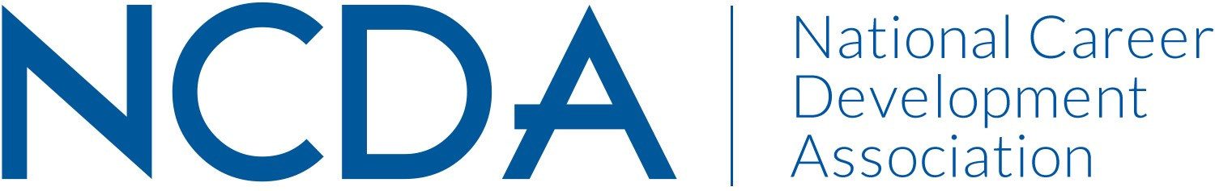

NCDA TECHNOLOGY COMMITTEE
Date of Report: March 6, 2026
Co-Chair: Dr. Erik Hines, PhD.
George Mason University
Professor, Counselor Education
ehines@gmu.edu
Co-Chair: Angie Thompson
University of Montana
Assistant Director & Career Coach, Student Engagement and AI Education
angie.thompson@mso.umt.edu
Committee Members:
Angie Thompson
Barbara Thomson
Candina Janicki
Darrin Carr
Dawna Reeves
Debra Ruddell
Dirk Matthews
Efraun Guzman-Rodriguez
Ellen Weaver Paquette
Eric Hines
Farrar Freeman
J Newman
JP Makela
Jaana Kettunen
James L Moore III
Janet Wall
Jennifer Villalobos
Jenny Xu
Julia Panke Makela
Julie Biggers
Kirk Thiemann
Kandina Koonce
Katherine (Kathyy) Battee-Freeman
Leigh Farrar-Freeman
Luke Gorham
Lydia Erickson
Lynne Orr
Marcela Mesa
Monique Russell
Rebecca Harrington
Rose Fuller
Sammy Stein
Tom Dubbels
Vanessa Rubinfield
Young Choi-Plass
Committee Activities to Date:
- Held three committee meetings to date, featuring live demonstrations, keynote speakers, and member led presentations focused on technology, AI, and innovation in career development.
- Hosted technology demonstrations, including a featured demo by Kadina Koonce, and presentations led by Janet Wall and other committee members.
- Led and participated in NCDA Tech Podcast, including planning an upcoming podcast with Denise Lawson on Digital Wallets prior to the June in person conference.
- Authored and published an article on Green AI introducing the PAUSE framework.
- Serving on the NCDA AI Task Force and actively reviewing national ethical standards for AI in higher education, as well as sustainable AI practices.
- Leading an NCDA panel presentation in June featuring committee members.
- Multiple committee members have been accepted to present at the 2026 NCDA Summer Conference, including Erik Hines, Janet Wall, Young Choi-Plass, Angie Thompson, and Jaana Kettunen.
- Continuing to submit and contribute monthly technology related content (“Tech Tips) and resources to NCDA initiatives.
- Partnering regularly with other NCDA committees to provide training, professional development opportunities, and cross committee engagement.
- Maintaining strong and growing engagement, with 35 active members and approximately 15 regular attendees at meetings and overall participation doubling or tripling during virtual sessions.
- All committee activities and contributions to date have been completed without allocated funding.
Projected Plan/Work Planned to be Completed through September 30:
• Deliver the NCDA Tech Committee panel presentation in June.
• Host an in person Tech Committee gathering at the NCDA Summer Conference to strengthen connections and increase engagement.
• Feature guest speakers during the conference meet and greet to expand visibility and involvement in the committee.
• Continue leading NCDA Tech Podcasts, including the upcoming Digital Wallets episode with Denise Lawson.
• Secure additional guest speakers for upcoming committee meetings.
• Continue publishing articles and contributing thought leadership on technology, AI, and career development.
• Continue active participation on the AI Task Force and ongoing review of ethical and sustainable AI standards.
• Maintain quarterly meetings with demonstrations, discussions, and professional development opportunities.
• Continue collaborating with other committees to support shared initiatives and member engagement (this is in planning and may result in a featured webinar).

Budget Requests:
• Requested funding for hors d’oeuvres for the in person meet and greet at the conference.
• Requested funding for NCDA Tech Committee merchandise to support visibility and engagement.
• At this time, we have not received a response regarding these budget requests.

